Bug Report.

Environment:
OS Windows 7

Common preconditions:
- run dumb.exe.
- Main window appears and no files opened or created.

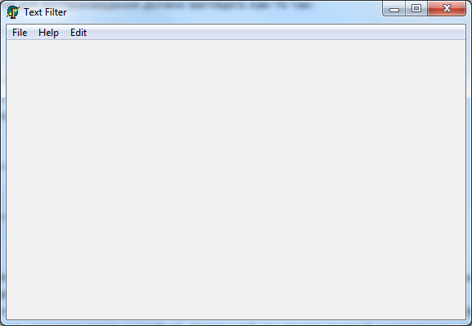

1.
Summary | 1. Main menu items wrong order.
Project | Text Filter
Component | Main menu.
Version | 0.0.001 hb
Severity:  - S1 Blocker  - S2 Critical  - S3 Major  - S4 Minor  - S5 Trivial | S3 Major
Приоритет:  - P1 High  - P2 Medium  - P3 Low | filled in by the project Manager
Status | New
Author | Alexander Pakhomov
Assigned To | the name of the developer
Steps to reproduce | 1. Look into Main menu
Result | “Help” item must placed between “File” and “Edit” items.  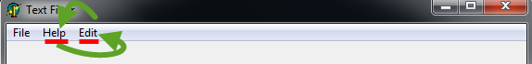
Expected Result | “Help” item must be placed righter of all Main menu items.

2.
Summary | 2. “Access violation” message after saving empty file..
Project | Text Filter
Component | Main menu.
Version | 0.0.001 hb
Severity:  - S1 Blocker  - S2 Critical  - S3 Major  - S4 Minor  - S5 Trivial | S2 Critical
Приоритет:  - P1 High  - P2 Medium  - P3 Low | filled in by the project Manager
Status | New
Author | Alexander Pakhomov
Assigned To | the name of the developer
Steps to reproduce | 1. Main menu -> File -> Save. (File save dialog appears)  2. Enter some file name.  3. Click “Save” button.
Result | “Access violation” message appears.  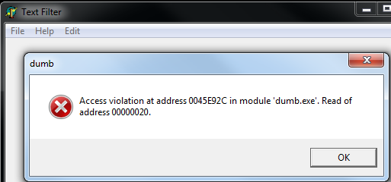
Expected Result | Empty *.dmb file must be saved without any error messages.  Alternatively in the step 1 when no files opened or created “Save” item in “File” menu must be disabled.  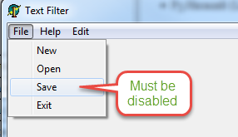

3.
Summary | 3. Spelling error in the “Cut” menu item.
Project | Text Filter
Component | Main menu.
Version | 0.0.001 hb
Severity:  - S1 Blocker  - S2 Critical  - S3 Major  - S4 Minor  - S5 Trivial | S5 Trivial
Приоритет:  - P1 High  - P2 Medium  - P3 Low | filled in by the project Manager
Status | New
Author | Alexander Pakhomov
Assigned To | the name of the developer
Steps to reproduce | 1. Main menu -> Edit (“Edit” menu appears.)
Result | Spelling error in the “Cat” menu item.  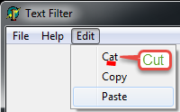
Expected Result | “Cat” menu item must be a “Cut”.

4.
Summary | 4. “Edit” menu items are not disabled when no files opened or created.
Project | Text Filter
Component | Main menu.
Version | 0.0.001 hb
Severity:  - S1 Blocker  - S2 Critical  - S3 Major  - S4 Minor  - S5 Trivial | S4 Minor
Приоритет:  - P1 High  - P2 Medium  - P3 Low | filled in by the project Manager
Status | New
Author | Alexander Pakhomov
Assigned To | the name of the developer
Steps to reproduce | 1. Main menu -> Edit (“Edit” menu appears.)
Result | “Cut”, “Copy” and “Paste” enabled.  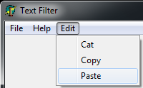
Expected Result | “Cut”, “Copy” and “Paste” must be disabled because there are no file created and no data to edit.

5.
Summary | 5. Spelling error in the “About” window.
Project | Text Filter
Component | “About” window.
Version | 0.0.001 hb
Severity:  - S1 Blocker  - S2 Critical  - S3 Major  - S4 Minor  - S5 Trivial | S5 Trivial
Приоритет:  - P1 High  - P2 Medium  - P3 Low | filled in by the project Manager
Status | New
Author | Alexander Pakhomov
Assigned To | the name of the developer
Steps to reproduce | 1. Main menu -> Help -> About (“About” window appears)
Result | Spelling error in the Product name field in the word “Teknics”.  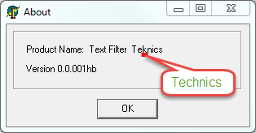
Expected Result | “Teknics” must be “Technics”.

6.
Summary | 6. “About” window is not respond.
Project | Text Filter
Component | “About” window.
Version | 0.0.001 hb
Severity:  - S1 Blocker  - S2 Critical  - S3 Major  - S4 Minor  - S5 Trivial | S2 Critical
Приоритет:  - P1 High  - P2 Medium  - P3 Low | filled in by the project Manager
Status | New
Author | Alexander Pakhomov
Assigned To | the name of the developer
Steps to reproduce | - Main menu -> Help -> About (“About” window appears)  - Click “OK” Button. (“About” window do not close and stuck).  - Click “OK” Button multiple times.
Result | Application do not respond.  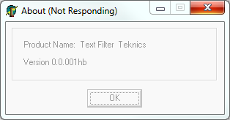
Expected Result | After click on “OK” button “About” window closed and main window is available.

7.
Summary | 7. Buttons “Add”, “Delete”, “Add filter”, “Delete filter” are not available without scrolling down..
Project | Text Filter
Component | Main Window.
Version | 0.0.001 hb
Severity:  - S1 Blocker  - S2 Critical  - S3 Major  - S4 Minor  - S5 Trivial | S3 Major
Приоритет:  - P1 High  - P2 Medium  - P3 Low | filled in by the project Manager
Status | New
Author | Alexander Pakhomov
Assigned To | the name of the developer
Steps to reproduce | 1. Main menu -> File -> New.(text filter form appears).
Result | Buttons “Add”, “Delete”, “Add filter”, “Delete filter” are not available without scrolling down.  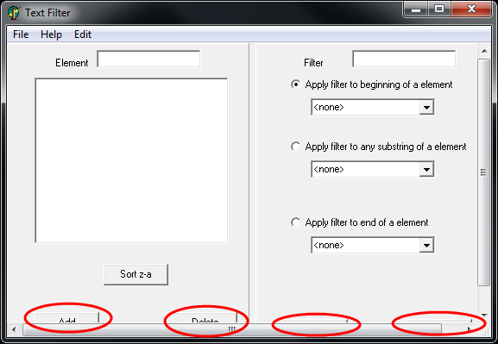  After scrolling down.  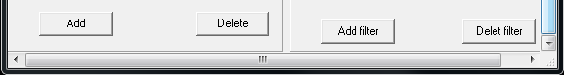
Expected Result | Buttons “Add”, “Delete”, “Add filter”, “Delete filter” are available without scrolling down.

8.
Summary | 8. Incorrect default size of application main window.
Project | Text Filter
Component | Main Window.
Version | 0.0.001 hb
Severity:  - S1 Blocker  - S2 Critical  - S3 Major  - S4 Minor  - S5 Trivial | S3 Major
Приоритет:  - P1 High  - P2 Medium  - P3 Low | filled in by the project Manager
Status | New
Author | Alexander Pakhomov
Assigned To | the name of the developer
Steps to reproduce | 1. Main menu -> File -> New.(text filter form appears).
Result | Horizontal and vertical scroll bars appears.  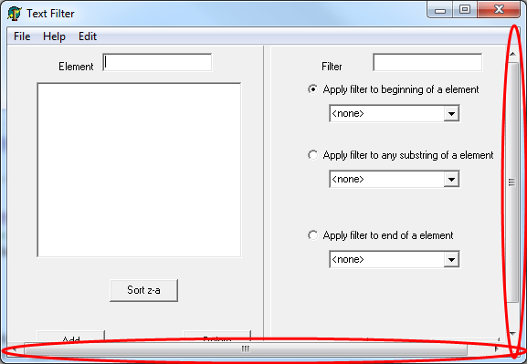
Expected Result | Text Filter form appears without any scrollbars and all controls are available.  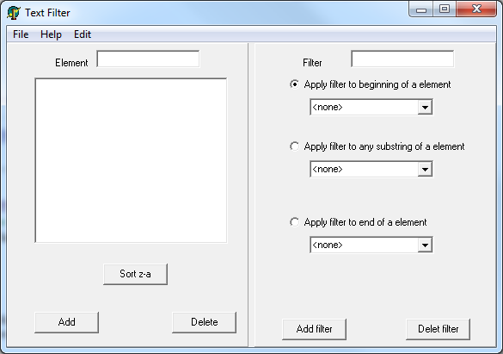

9.
Summary | 9. “Add”, “Delete”, “Add filter”, “Delete filter” buttons must be on the same level.
Project | Text Filter
Component | Filters.
Version | 0.0.001 hb
Severity:  - S1 Blocker  - S2 Critical  - S3 Major  - S4 Minor  - S5 Trivial | S4 Minor
Приоритет:  - P1 High  - P2 Medium  - P3 Low | filled in by the project Manager
Status | New
Author | Alexander Pakhomov
Assigned To | the name of the developer
Steps to reproduce | - Main menu -> File -> New.(text filter form appears).
Result | . “Add”, “Delete”, “Add filter”, “Delete filter” buttons placed in different levels.  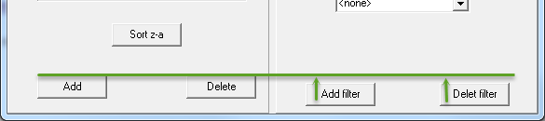
Expected Result | “Add”, “Delete”, “Add filter”, “Delete filter” buttons must be placed on the same level.

10.
Summary | 10. Spelling error in “Delet filter” button.
Project | Text Filter
Component | Filters.
Version | 0.0.001 hb
Severity:  - S1 Blocker  - S2 Critical  - S3 Major  - S4 Minor  - S5 Trivial | S4 Minor
Приоритет:  - P1 High  - P2 Medium  - P3 Low | filled in by the project Manager
Status | New
Author | Alexander Pakhomov
Assigned To | the name of the developer
Steps to reproduce | - Main menu -> File -> New.(text filter form appears).
Result | In the right down corner of window button “Delet filter” has spelling error.  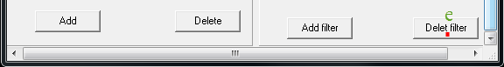
Expected Result | “Delet filter” must be “Delete filter”.

11.
Summary | 11. “Backspace” button do not work in “Element” field.
Project | Text Filter
Component | Elements.
Version | 0.0.001 hb
Severity:  - S1 Blocker  - S2 Critical  - S3 Major  - S4 Minor  - S5 Trivial | S4 Minor
Приоритет:  - P1 High  - P2 Medium  - P3 Low | filled in by the project Manager
Status | New
Author | Alexander Pakhomov
Assigned To | the name of the developer
Steps to reproduce | - Main menu -> File -> New.(text filter form appears).  - Print ‘123’ in the “Element” field.  - Push “Backspace” button.
Result | “Backspace” button do not erases printed text in the element field  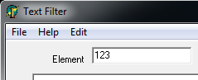
Expected Result | “Backspace” button erases printed text in the element field.

12.
Summary | 12. “Delete” button must be disabled when list of elements is empty.
Project | Text Filter
Component | Elements.
Version | 0.0.001 hb
Severity:  - S1 Blocker  - S2 Critical  - S3 Major  - S4 Minor  - S5 Trivial | S4 Major
Приоритет:  - P1 High  - P2 Medium  - P3 Low | filled in by the project Manager
Status | New
Author | Alexander Pakhomov
Assigned To | the name of the developer
Steps to reproduce | - Main menu -> File -> New.(text filter form appears).
Result | List of elements is empty and “Delete” button is enabled.  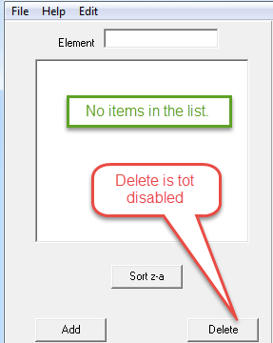
Expected Result | “Delete” button must be disabled.

13.
Summary | 13. “Delete” operation from elements list takes a long time and application is stuck.
Project | Text Filter
Component | Elements.
Version | 0.0.001 hb
Severity:  - S1 Blocker  - S2 Critical  - S3 Major  - S4 Minor  - S5 Trivial | S3 Major
Приоритет:  - P1 High  - P2 Medium  - P3 Low | filled in by the project Manager
Status | New
Author | Alexander Pakhomov
Assigned To | the name of the developer
Steps to reproduce | - Main menu -> File -> New.(text filter form appears).  - Print ‘123’ in the “Element” field.  - Click “Add” Button (“123” item present in the elements list)  - Select “123” item in the element list.  - Click “Delete” button.
Result | Application is stuck on 2 seconds. After 2 seconds “123” item fades from element list.
Expected Result | “Delete” button disabled ->Application do not stuck while “123” item fades from element list. (Optional “Add” button disabled to and some status bar showed until delete process goes) -> After “123” item fades from element list “Delete” button become enabled.

14.
Summary | 14. “Delete” button must be disabled when no items selected in Elements list.
Project | Text Filter
Component | Elements.
Version | 0.0.001 hb
Severity:  - S1 Blocker  - S2 Critical  - S3 Major  - S4 Minor  - S5 Trivial | S3 Major
Приоритет:  - P1 High  - P2 Medium  - P3 Low | filled in by the project Manager
Status | New
Author | Alexander Pakhomov
Assigned To | the name of the developer
Steps to reproduce | - Main menu -> File -> New.(text filter form appears).  - Print ‘1’ in the “Element” field.  - Click “Add” Button (“1” item present in the elements list)  - Print ‘2’ in the “Element” field.  - Click “Add” Button  - Print ‘3’ in the “Element” field.  - Click “Add” Button (“3”,“2” and “1” item present in the elements list)
Result | No Elements selected. "Delete" button enabled.  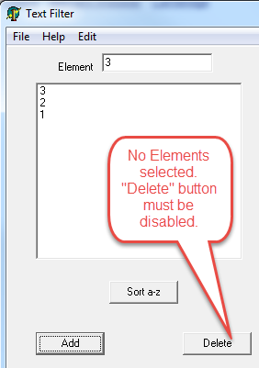
Expected Result | “Delete” button disabled. Only after any element selection “Delete” button enabled  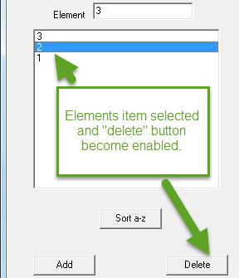

15.
Summary | 15. “Access violation” message after click “Exit” in “File” men.
Project | Text Filter
Component | “File” menu
Version | 0.0.001 hb
Severity:  - S1 Blocker  - S2 Critical  - S3 Major  - S4 Minor  - S5 Trivial | S2 Critical
Приоритет:  - P1 High  - P2 Medium  - P3 Low | filled in by the project Manager
Status | New
Author | Alexander Pakhomov
Assigned To | the name of the developer
Steps to reproduce | - Main menu -> File -> Exit.
Result | “Access violation” message appears.  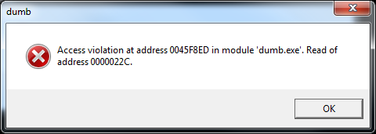
Expected Result | Text Filter application shooting down.

16.
Summary | 16. Text Filter closed without “Save Changes?” confirmation.
Project | Text Filter
Component | Elements.
Version | 0.0.001 hb
Severity:  - S1 Blocker  - S2 Critical  - S3 Major  - S4 Minor  - S5 Trivial | S3 Major
Приоритет:  - P1 High  - P2 Medium  - P3 Low | filled in by the project Manager
Status | New
Author | Alexander Pakhomov
Assigned To | the name of the developer
Steps to reproduce | - Main menu -> File -> New.(text filter form appears).  - Print ‘123’ in the “Element” field.  - Click “Add” Button (“123” item present in the elements list)  - Click “Cross” button in the top right corner of Text Filter Window.  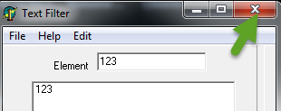
Result | Text Filter closed without “Save Changes?” confirmation.
Expected Result | “There are unsaved changes. When you close the application, they will be lost. Do you want to save your changes?” (Yes/No) dialog appears. If User selects “Yes” file save dialog appears. If user selects “No” Text Filter closed without saving any changes.  Same actions must be after Click on Main menu -> File -> Exit.

17.
Summary | 17. “File->New” do not update Text Filter form.
Project | Text Filter
Component | “File” menu.
Version | 0.0.001 hb
Severity:  - S1 Blocker  - S2 Critical  - S3 Major  - S4 Minor  - S5 Trivial | S3 Major
Приоритет:  - P1 High  - P2 Medium  - P3 Low | filled in by the project Manager
Status | New
Author | Alexander Pakhomov
Assigned To | the name of the developer
Steps to reproduce | - Main menu -> File -> New.(text filter form appears).  - Print ‘123’ in the “Element” field.  - Click “Add” Button (“123” item present in the elements list)  - Print “1” in the “Filter” field.  - Click “Add Filter” button. (“1” item present in the “beginning of element” filters list).  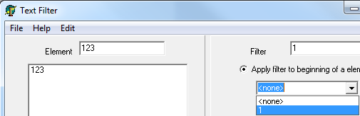  6 Main menu -> File -> New
Result | Text Filter form is not updated.
Expected Result | “Do you want to save your changes?” (Yes/No) dialog appears. If User selects “Yes” file save dialog appears. If user selects “No” all elements and filter items in the form must be deleted.

18.
Summary | 18. There are no indication of edited file name.
Project | Text Filter
Component | Header of main window.
Version | 0.0.001 hb
Severity:  - S1 Blocker  - S2 Critical  - S3 Major  - S4 Minor  - S5 Trivial | S4 Minor
Приоритет:  - P1 High  - P2 Medium  - P3 Low | filled in by the project Manager
Status | New
Author | Alexander Pakhomov
Assigned To | the name of the developer
Steps to reproduce | - Main menu -> File -> New.(text filter form appears).  - 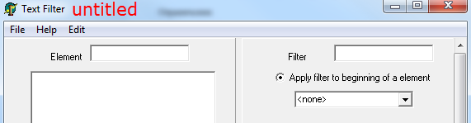  - Print ‘123’ in the “Element” field.  - Click “Add” Button (“123” item present in the elements list)  - Main menu -> File -> Save (File Save dialog appears)  - Save file as “1.dmb”  - Main menu -> File -> Open(File Open dialog appears)  - Open “1.dmb”.(File opened)
Result | There are no information in the header of Text Filter about opened file.  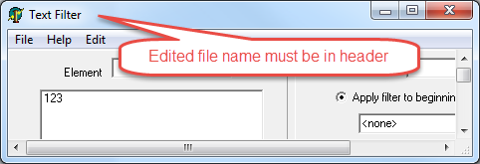
Expected Result | “1.dmb Text Filter” printed in the header of the Text Filter Main window.

19.
Summary | 19. Internal error after more then 10 filter items in “Apply filter to beginning of a element” list..
Project | Text Filter
Component | Filters.
Version | 0.0.001 hb
Severity:  - S1 Blocker  - S2 Critical  - S3 Major  - S4 Minor  - S5 Trivial | S2 Critical
Приоритет:  - P1 High  - P2 Medium  - P3 Low | filled in by the project Manager
Status | New
Author | Alexander Pakhomov
Assigned To | the name of the developer
Steps to reproduce | - Main menu -> File -> New.(text filter form appears).  - Print “1” in the “Filter” field.  - Click “Add Filter” button. (“1” item present in the “beginning of element” filters list).  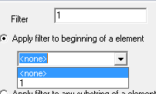  - Click “Add Filter” button more then 10 times.
Result | Internal error appears.  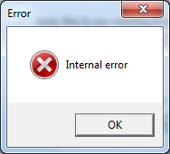
Expected Result | After trying to add more then10 filter items “Cannot add a new filter: maximum reached!” message appears.

20.
Summary | 20. Application stuck and get maximum CPU time adding more then 10 filter items in “Apply filter to any substring of a element” list.
Project | Text Filter
Component | Filters.
Version | 0.0.001 hb
Severity:  - S1 Blocker  - S2 Critical  - S3 Major  - S4 Minor  - S5 Trivial | S2 Critical
Приоритет:  - P1 High  - P2 Medium  - P3 Low | filled in by the project Manager
Status | New
Author | Alexander Pakhomov
Assigned To | the name of the developer
Steps to reproduce | - Main menu -> File -> New.(text filter form appears).  - Print “1” in the “Filter” field.  - Select radio button “Apply filter to any substring of a element”  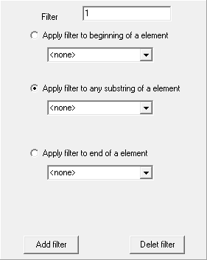  - Click “Add Filter” button more then 10 times.
Result | Application stuck and gets maximum CPU time  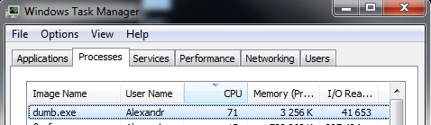  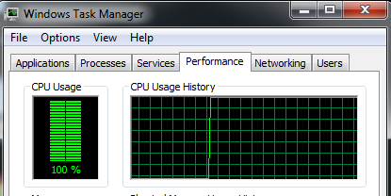
Expected Result | After trying to add more then10 filter items “Cannot add a new filter: maximum reached!” message appears.

21.
Summary | 21. There are no messages after adding more then 10 filter items in “Apply filter to end of a element” list.
Project | Text Filter
Component | Filters.
Version | 0.0.001 hb
Severity:  - S1 Blocker  - S2 Critical  - S3 Major  - S4 Minor  - S5 Trivial | S4 Minor
Приоритет:  - P1 High  - P2 Medium  - P3 Low | filled in by the project Manager
Status | New
Author | Alexander Pakhomov
Assigned To | the name of the developer
Steps to reproduce | - Main menu -> File -> New.(text filter form appears).  - Print “1” in the “Filter” field.  - Select radio button “Apply filter to end of a element”  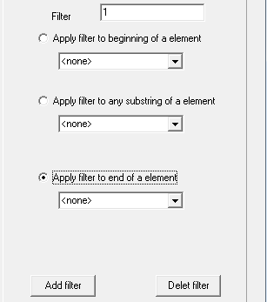  - Click “Add Filter” button more then 10 times.
Result | There are no any messages.
Expected Result | After trying to add more then10 filter items “Cannot add a new filter: maximum reached!” message appears.

22.
Summary | 22. Error in sorting algorithm.
Project | Text Filter
Component | Business Logic.
Version | 0.0.001 hb
Severity:  - S1 Blocker  - S2 Critical  - S3 Major  - S4 Minor  - S5 Trivial | S3 Major
Приоритет:  - P1 High  - P2 Medium  - P3 Low | filled in by the project Manager
Status | New
Author | Alexander Pakhomov
Assigned To | the name of the developer
Steps to reproduce | - Main menu -> File -> New.(text filter form appears).  - Print “a” in the “Element” field.  - Click “Add” button.  - Print “aa” in the “Element” field.  - Click “Add” button.  - Print “aaa” in the “Element” field.  - Click “Add” button. (three element item in list: “a”,”aa”,”aaa”.)  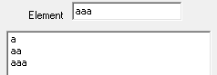  - Click “Sort z-a” Button.
Result | Elements order is “aa”, “aaa” , “a”  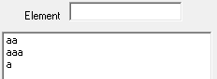
Expected Result | Elements order is “aaa”, “aa” , “a”  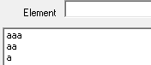

23.
Summary | 23. Error in filter “to beginning” algorithm.
Project | Text Filter
Component | Business Logic.
Version | 0.0.001 hb
Severity:  - S1 Blocker  - S2 Critical  - S3 Major  - S4 Minor  - S5 Trivial | S3 Major
Приоритет:  - P1 High  - P2 Medium  - P3 Low | filled in by the project Manager
Status | New
Author | Alexander Pakhomov
Assigned To | the name of the developer
Steps to reproduce | - Main menu -> File -> New.(text filter form appears).  - Print “a” in the “Element” field.  - Click “Add” button.  - Print “aa” in the “Element” field.  - Click “Add” button.  - Print “aaa” in the “Element” field.  - Click “Add” button. (three element item in list: “a”,”aa”,”aaa”.)  - Print “a” in the “Filter” field.  - Click “Add Filter” button.  - Print “aa” in the “Filter” field.  - Click “Add Filter” button.  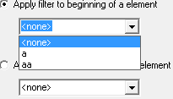  - Select “aa” filter item of “beginning” filter. (“aa” and “aaa” items presented in elements list).  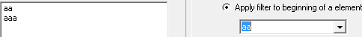  13 Select “a” filter item of “beginning” filter.
Result | There are no items presented in the elements list.
Expected Result | “a”,”aa”,”aaa” items presented in elements list

24.
Summary | 24. Error in filter “to any substring” algorithm.
Project | Text Filter
Component | Business Logic.
Version | 0.0.001 hb
Severity:  - S1 Blocker  - S2 Critical  - S3 Major  - S4 Minor  - S5 Trivial | S3 Major
Приоритет:  - P1 High  - P2 Medium  - P3 Low | filled in by the project Manager
Status | New
Author | Alexander Pakhomov
Assigned To | the name of the developer
Steps to reproduce | - Main menu -> File -> New.(text filter form appears).  - Print “1” in the “Element” field.  - Click “Add” button.  - Print “11” in the “Element” field.  - Click “Add” button.  - Print “111” in the “Element” field.  - Click “Add” button. (three element item in list: “1”,”11”,”111”.)  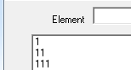  - Print “11” in the “Filter” field.  - Select “Apply filter to any substring of a element” radio button.  - Click “Add Filter” button.  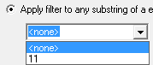  - Select “11” filter item of “to any substring” filter.  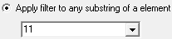
Result | There are only “11” item presented in the elements list.  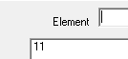
Expected Result | ”11”,”111” items presented in elements list

25.
Summary | 25. First error in filter “to end of a element” algorithm.
Project | Text Filter
Component | Business Logic.
Version | 0.0.001 hb
Severity:  - S1 Blocker  - S2 Critical  - S3 Major  - S4 Minor  - S5 Trivial | S3 Major
Приоритет:  - P1 High  - P2 Medium  - P3 Low | filled in by the project Manager
Status | New
Author | Alexander Pakhomov
Assigned To | the name of the developer
Steps to reproduce | - Main menu -> File -> Open (File open dialog appears).  - Open attached aaa111.dmb (“1”,”11”,”111”,”a”,”aa”,”aaa elements and “1”,”11”,”a”,”aa”, “aaa”, “aaaa” and “aaaaa” filter items of “Apply filter to end of a element” present)  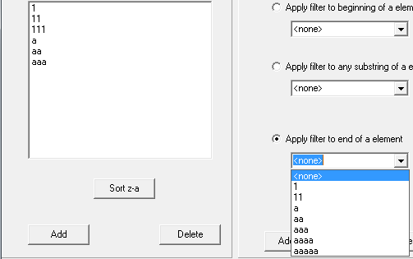  - Select “Apply filter to end of a element”.  - Select “a” item in dropdown list.  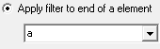
Result | Only “a” items presented in the elements list.  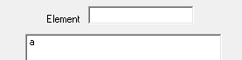
Expected Result | “a”,”aa”,”aaa” items presented in elements list
26.
Summary | 26. Second error in filter “to end of a element” algorithm.
Project | Text Filter
Component | Business Logic.
Version | 0.0.001 hb
Severity:  - S1 Blocker  - S2 Critical  - S3 Major  - S4 Minor  - S5 Trivial | S3 Major
Приоритет:  - P1 High  - P2 Medium  - P3 Low | filled in by the project Manager
Status | New
Author | Alexander Pakhomov
Assigned To | the name of the developer
Steps to reproduce | - Main menu -> File -> Open (File open dialog appears).  - Open attached aaa111.dmb (“1”,”11”,”111”,”a”,”aa”,”aaa” elements and “1”,”11”,”a”,”aa”, “aaa”, “aaaa” and “aaaaa” filter items of “Apply filter to end of a element” present)  - Select “Apply filter to end of a element”.  - Select “aa” item in dropdown list.  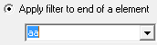
Result | “1”, “a”, “aa” items presented in the elements list.  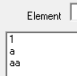
Expected Result | ”aa”,”aaa” items presented in elements list

27.
Summary | 27. Third error in filter “to end of a element” algorithm.
Project | Text Filter
Component | Business Logic.
Version | 0.0.001 hb
Severity:  - S1 Blocker  - S2 Critical  - S3 Major  - S4 Minor  - S5 Trivial | S3 Major
Приоритет:  - P1 High  - P2 Medium  - P3 Low | filled in by the project Manager
Status | New
Author | Alexander Pakhomov
Assigned To | the name of the developer
Steps to reproduce | - Main menu -> File -> Open (File open dialog appears).  - Open attached aaa111.dmb (“1”,”11”,”111”,”a”,”aa”,”aaa” elements and “1”,”11”,”a”,”aa”, “aaa”, “aaaa” and “aaaaa” filter items of “Apply filter to end of a element” present)  - Select “Apply filter to end of a element”.  - Select “aaa” item in dropdown list.  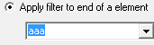
Result | “11”, “aa”, “aaa” items presented in the elements list.  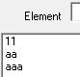
Expected Result | ”aaa” item presented in elements list

28.
Summary | 28. Fourth error in filter “to end of a element” algorithm.
Project | Text Filter
Component | Business Logic.
Version | 0.0.001 hb
Severity:  - S1 Blocker  - S2 Critical  - S3 Major  - S4 Minor  - S5 Trivial | S3 Major
Приоритет:  - P1 High  - P2 Medium  - P3 Low | filled in by the project Manager
Status | New
Author | Alexander Pakhomov
Assigned To | the name of the developer
Steps to reproduce | - Main menu -> File -> Open (File open dialog appears).  - Open attached aaa111.dmb (“1”,”11”,”111”,”a”,”aa”,”aaa” elements and “1”,”11”,”a”,”aa”, “aaa”, “aaaa” and “aaaaa” filter items of “Apply filter to end of a element” present)  - Select “Apply filter to end of a element”.  - Select “aaa” item in dropdown list.  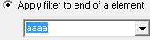
Result | “111”, and “aaa” items presented in the elements list.  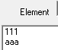
Expected Result | There are no items presented in elements list

29.
Summary | 29. “Access violation” message after closing application..
Project | Text Filter
Component | Main window.
Version | 0.0.001 hb
Severity:  - S1 Blocker  - S2 Critical  - S3 Major  - S4 Minor  - S5 Trivial | S2 Critical
Приоритет:  - P1 High  - P2 Medium  - P3 Low | filled in by the project Manager
Status | New
Author | Alexander Pakhomov
Assigned To | the name of the developer
Steps to reproduce | 1. Main menu -> File -> Open. (File save dialog appears)  2. Open attached 123.dmb.  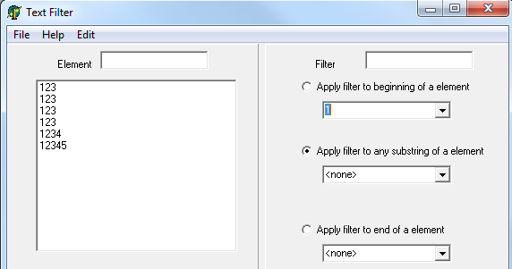  3. Click “Cross” button in top right corner of Text Filter window to close application.
Result | “Access violation” message appears.  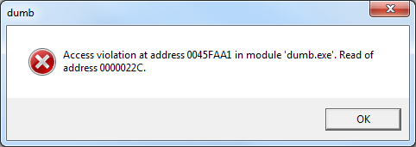
Expected Result | Application closes without error message.

30.
Summary | 30. There are no information in “Help” window.
Project | Text Filter
Component | “Help” window.
Version | 0.0.001 hb
Severity:  - S1 Blocker  - S2 Critical  - S3 Major  - S4 Minor  - S5 Trivial | S4 Minor
Приоритет:  - P1 High  - P2 Medium  - P3 Low | filled in by the project Manager
Status | New
Author | Alexander Pakhomov
Assigned To | the name of the developer
Steps to reproduce | - Main menu -> Help -> index (Help window appears).  - Trying to click any item of Left menu in Help window.
Result | Navigation to the webpage was canceled  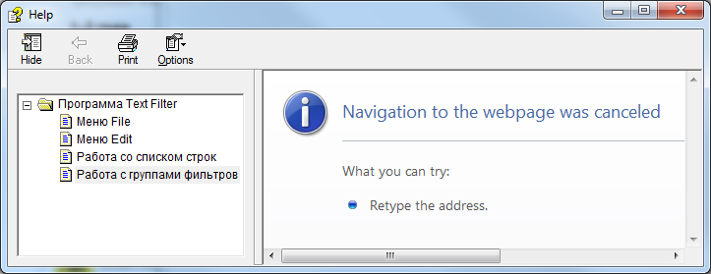.
Expected Result | Appropriate text shown in “Help” Window.

31.
Summary | 31. “Cut” and “Copy” items in “Edit” menu are not disabled when no text selected.
Project | Text Filter
Component | Edit menu.
Version | 0.0.001 hb
Severity:  - S1 Blocker  - S2 Critical  - S3 Major  - S4 Minor  - S5 Trivial | S4 Minor
Приоритет:  - P1 High  - P2 Medium  - P3 Low | filled in by the project Manager
Status | New
Author | Alexander Pakhomov
Assigned To | the name of the developer
Steps to reproduce | - Main menu -> File -> New (text filter form appears).  - Right click on “Element” field (context menu appears and “Cut”, “Copy” items are disabled).  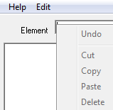  Main menu -> Edit
Result | “Cut” and “Copy” items are enabled.  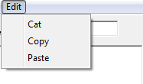
Expected Result | “Cut” and “Copy” items are disabled.

32.
Summary | 32. “Access violation” message appears after clicking on “Delete” and “Add” buttons in empty elements list.
Project | Text Filter
Component | Edit menu.
Version | 0.0.001 hb
Severity:  - S1 Blocker  - S2 Critical  - S3 Major  - S4 Minor  - S5 Trivial | S3 Major
Приоритет:  - P1 High  - P2 Medium  - P3 Low | filled in by the project Manager
Status | New
Author | Alexander Pakhomov
Assigned To | the name of the developer
Steps to reproduce | - Main menu -> File -> New (text filter form appears).  - Click “Delete” button.  - Click “Add” button
Result | “Access violation” message appears  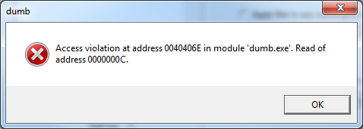
Expected Result | There is no error message. Empty string adds in Elements list.

33.
Summary | 33. Focus doesn’t set into “Element” field by default.
Project | Text Filter
Component | Text Filter form.
Version | 0.0.001 hb
Severity:  - S1 Blocker  - S2 Critical  - S3 Major  - S4 Minor  - S5 Trivial | S4 Minor
Приоритет:  - P1 High  - P2 Medium  - P3 Low | filled in by the project Manager
Status | New
Author | Alexander Pakhomov
Assigned To | the name of the developer
Steps to reproduce | - Main menu -> File -> New (text filter form appears).
Result | After pressing “Tab” button focus sets into “Element” field.
Expected Result | focus sets into “Element” field by default.

34.
Summary | 34. “Ctrl + C” and “Ctrl +V” don’t work in “Element” field.
Project | Text Filter
Component | Edit menu.
Version | 0.0.001 hb
Severity:  - S1 Blocker  - S2 Critical  - S3 Major  - S4 Minor  - S5 Trivial | S4 Minor
Приоритет:  - P1 High  - P2 Medium  - P3 Low | filled in by the project Manager
Status | New
Author | Alexander Pakhomov
Assigned To | the name of the developer
Steps to reproduce | - Main menu -> File -> New (text filter form appears).  - Type “123” into “Element” field  - Select “123”.  - “Ctrl + C”  - Push “End” button.  - “Ctrl +V”
Result | “123” present in “Element” field.
Expected Result | “123123” present in “Element” field.

